**API Response by Postman**

1. Rest API Untuk Karyawan + Detail
2. POST - {{host}}/v1/idstar/karyawan/save

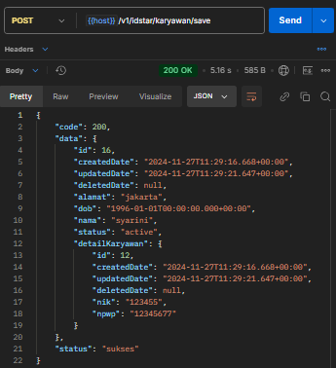

1. PUT - {{host}}/v1/idstar/karyawan/update

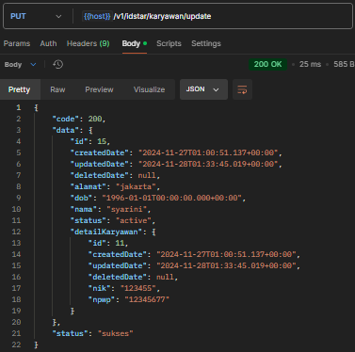

1. GET LIST - {{host}}/v1/idstar/karyawan/list

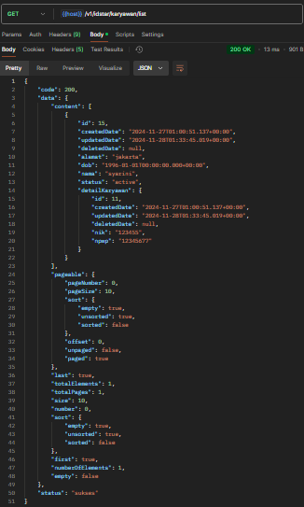

1. GET ID - {{host}}/v1/idstar/karyawan/{id}

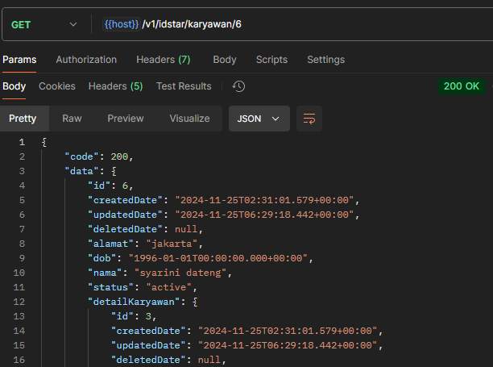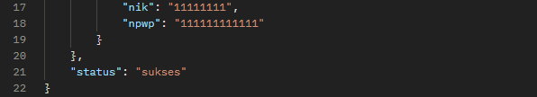

1. DELETE - {{host}}/v1/idstar/karyawan/delete

1. Rest API Untuk Rekening
2. POST - {{host}}/v1/idstar/rekening/save

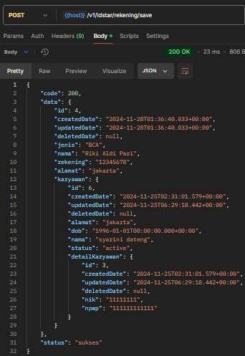

1. PUT - {{host}}/v1/idstar/rekening/update

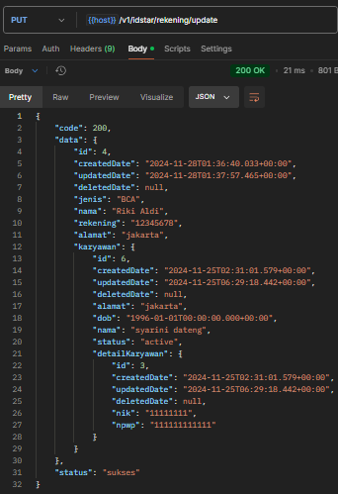

1. GET ID - {{host}}/v1/idstar/rekening/{id}

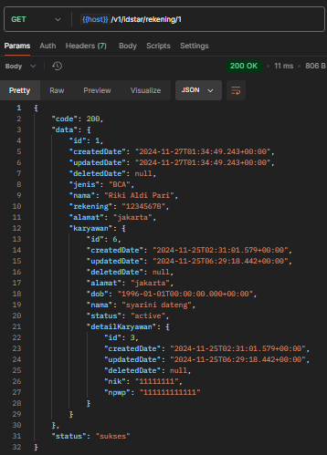

1. GET List - {{host}}/v1/idstar/rekening/list

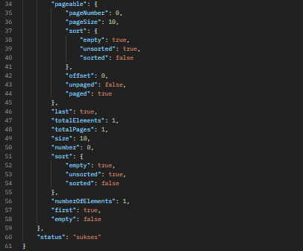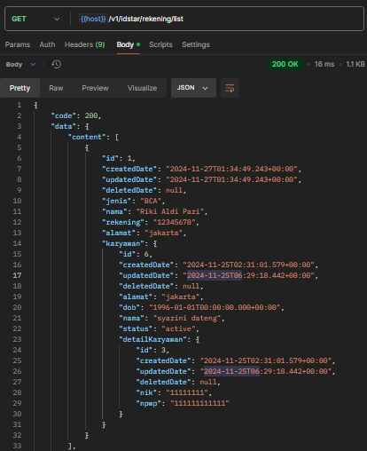

1. DELETE - {{host}}/v1/idstar/rekening/delete

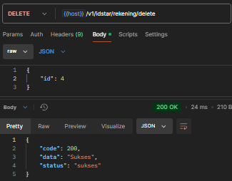

1. Rest API Untuk Training
2. POST - {{host}}/v1/idstar/training/save

1. PUT - {{host}}/v1/idstar/training/update

1. GET LIST - {{host}}/v1/idstar/training/list

1. GET ID - {{host}}/v1/idstar/training/{id}

1. DELETE - {{host}}/v1/idstar/training/delete

1. Rest API Untuk KaryawanTraining
2. POST - {{host}}/v1/idstar/karyawan-training/save

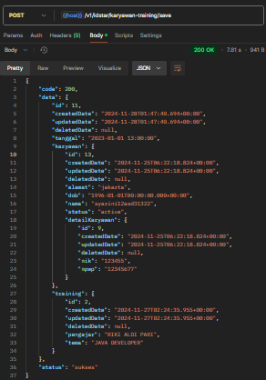

1. A screenshot of a computer program

   Description automatically generatedPUT - {{host}}/v1/idstar/karyawan-training/update

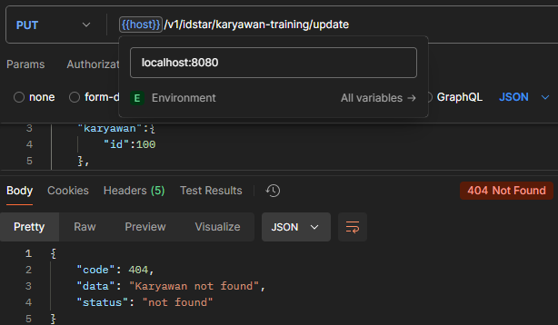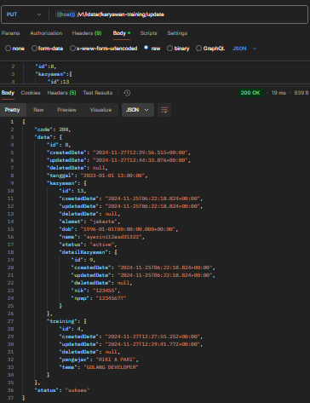

1. GET LIST - {{host}}/v1/idstar/karyawan-training/list

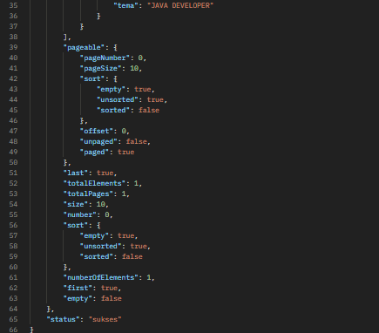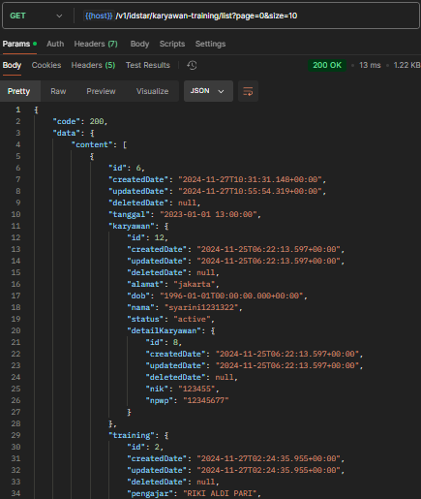

1. GET ID - {{host}}/v1/idstar/karyawan-training/{id}

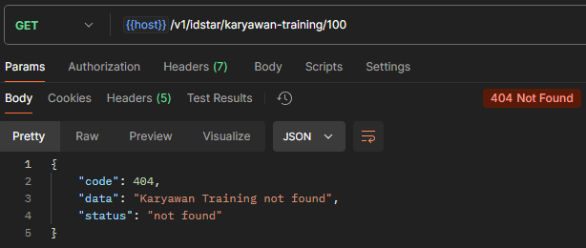

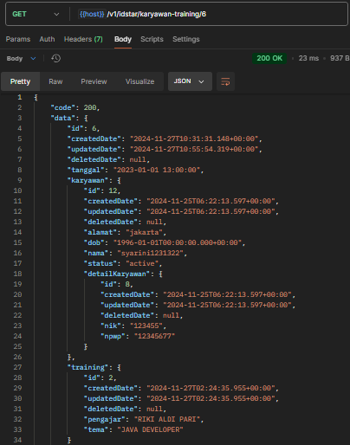

1. DELETE {{host}}/v1/idstar/karyawan-training/delete

